Clavate HAND SET Tag Reader
Operating Manual
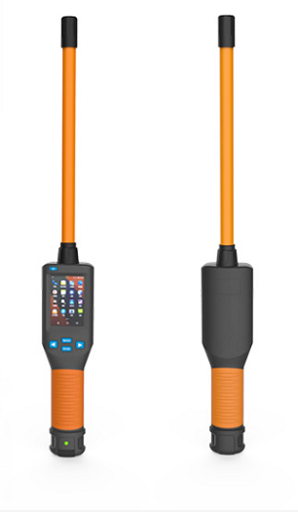

Contents
I. Overview 1
II. Performance Parameters 1
Product performance parameters are shown in Table 1. 1
Reading time 1
III. Function Introduction and Operation Instructions 2
1. Display Interface Description 2
2. Basic Operations 3
Power On 3
Scan Labels 3
Auto Power Off 3
3 .System Settings 3
1: Return to the Main Interface 4
2: Language Settings 4
3: Storage Settings 5
4: Reread Settings 5
5: Data Tag 5
6: Data Comparison 5
7: Buzzer Settings 5
8: Delete ReadCard Data 5
9: Version Number 5
10: ReadCard Selection (Temporarily Undeveloped) 5
11: Bluetooth Switch Settings 5
12: Power Off 6
13: Restore Factory Settings 6
14: System Time Settings 6
IV. Data Transmission Management 6
1Database Management Software 6
2 Wireless Data Transmission Function 7
Bluetooth 7
V. Notes 7
VI. Packing List 8

I. Overview
The hand set adopts wireless reading mode and supports electronic tags in FDX-B and FDX-A (ISO11784/85) formats.
The product adopts a high-brightness LCD (480x320) display screen which can be displayed clearly in indoor or outdoor glare conditions. The storage function that products owns originally can store up to 20,000 tag information. Users can read the stored information to the computer for data management via USB data cable or wireless connection.
The product has stable performance and simple operation, which is suitable for animal management, traceability management, railway inspection and other asset management fields.

II. Performance Parameters

Product performance parameters are shown in Table 1.
Table 1 Hand set performance parameters
Working frequency | 134.2KHz
Label format | FDX-B、FDX-A (ISO11784/85)
Sensing distance | FDX-B：  2*12mm glass tube label>10cm  30mm animal ear tag >20cm  FDX-A：  2*12mm glass tube label >10cm  Note: (relevant to the card reader and the usage environment)
Standard | ISO11784/85
Reading time | Less than 100ms
Signal indication | 480*320 high brightness LCD、buzzer
Power supply | Lithium battery
Power consumption | 0.4W
Power consumption | 20000 pieces of information (tag code + time)
Battery life capacity | More than 10,000 readings when it is fully charged.
Battery capacity | 3000mA
Communication interface | USB2.0、Bluetooth

III. Function Introduction and Operation Instructions
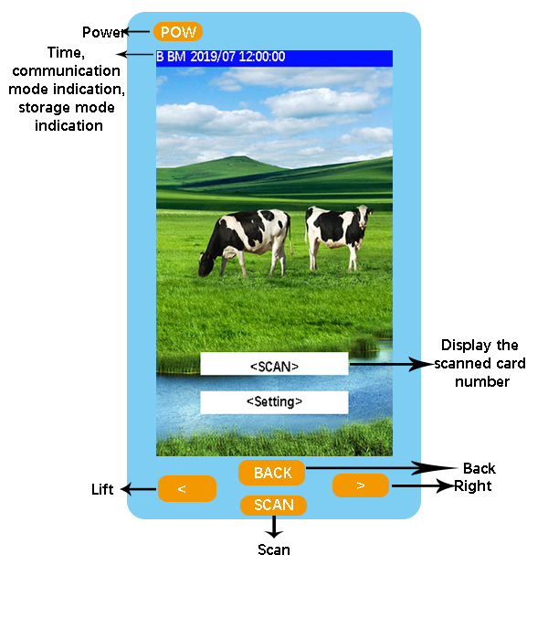
Device Operation Interface

1. Display Interface Description
The reader brings its own a 480*320 high-brightness LCD display, which can simultaneously display electronic tag information, time, communication mode indications, and storage mode indications. The display interface is shown in Figure 1.
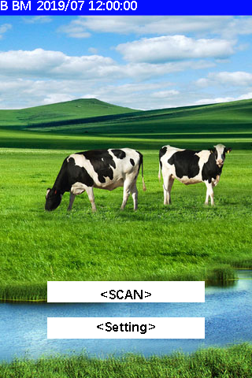
Figure 1 The function interface is displayed.

2. Basic Operations

Power On
Press the POW button in the power-off state for a long time, then, the system will power on and enter the scan label display interface.

Scan Labels
In the scan label display interface, start scanning the label by pressing the “Scan” button. After the tag information is read, the buzzer prompts and displays the current tag information on the screen. If the tag information can not be scanned within 10 seconds, the buzzer sounds will last long and display “No tag!”.

Auto Power Off
In the power-on state, there is no key operation or data transmission within 30 seconds, and the system will automatically shut down and enter the dormant state.

3 .System Settings
Press the left and right button in the power-on state, and then the reader enters the setting mode. The display interface is shown as below, and the left and right buttons (‘<’ and ‘>’) can be used to move the “arrow” cursor so as to select different functions for setting.
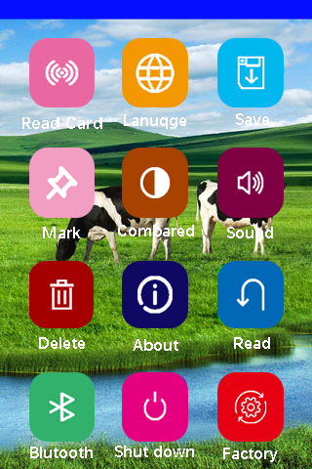
Icon interface
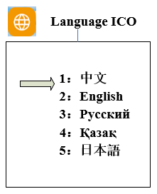
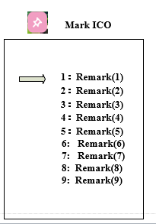
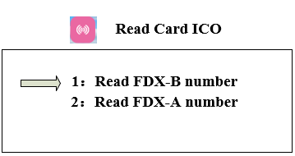

1: Return to the Main Interface
Press the return key in the icon interface. Return to the scanning interface menu and click the “SCAN” button so as to return to the main screen of the power-on scanning.

2: Language Settings
The factory default language of the hand set is Chinese.
If there is the need to change the language, move the “arrow” cursor to the “Language Settings” menu and press the “SCAN” button to enter the language setting menu and to select with the “arrow” cursor.
(Note: The language that the device brings by its own is Chinese, English, Russian, Japanese.)

3: Storage Settings
Move the “arrow” cursor to the “Storage Settings” menu and press the “SCAN” button to switch between “Y” and “N”.
(Note: When the storage mode is set to “Y”, the reader will automatically store the tag type, ID number, and operation time after the reader reads the tag information. If the storage mode is set to “N”, no information will be stored.)

4: Reread Settings
Move the “arrow” cursor to the “Reread Settings” menu and press the “SCAN” button to switch between “Y” and “N”.
(Note: If the reread mode is set to the “Y” mode, the hand set will save the same or different tag information read into the memory; when it is set to the “N” mode, the read tag information will be the same as the memory. When the tag letter is not stored, the current data is not stored and the buzzer will sound twice.)

5: Data Tag
Move the “arrow” cursor to the “Data Mark” menu, click the “SCAN” button to enter the data mark menu for marking, and the data read by the factory device is not marked by default.
(Note: This function is the data tag function. Nine different marks can be set to mark the type of tag to be read.)

6: Data Comparison
Move the “arrow” cursor to the “Data Contrast” menu, press the “SCAN” button to switch between “Y” and “N”. After setting the “Y” mode, the device can enable the contrast function and the data read will be compared with the data that is required when importing the hand set. If there is the same label information, the buzzer will sound three times.

7: Buzzer Settings
Move the “arrow” cursor to the “Buzzer” menu and press the “SCAN” button to switch between “Y” and “N”.
(Note: “Y” means the buzzer will be turned on in the voice mode, and “N” means the buzzer will be turned off in the silent mode.)

8: Delete ReadCard Data
Move the “arrow” cursor to the “Delete Data” menu and double-click “SCAN” to delete all the data in the memory.
(Note: After deleting the data, the data cannot be recovered. Users shall operate with caution.)

9: Version Number
Move the “arrow” cursor to the “Version Number” menu and press the “SCAN” button to query the factory version information and website address of the device.

10: ReadCard Selection (Temporarily Undeveloped)
Move the “arrow” cursor to the “Read Card Selection” menu and click the “SCAN” button to enter the card reading mode selection.
(Note: The device defaults to reading the ID number. It is possible to select the mode to be read through the cursor. This function only supports FDX-B type tags.

11: Bluetooth Switch Settings
Move the “arrow” cursor to the “Bluetooth” menu, press the “SCAN” button so as to switch between the buttons of “Y” and “N”. If it is set to the “Y” mode, the Bluetooth function of the hand set will be turned on. If it is set to the “N” mode, the Bluetooth function of the hand set will be turned off.
(Note: After Bluetooth is turned on, there is the need to connect with the relevant Bluetooth device. After the successful connection, the information read by the hand set will send the current tag ID number to the relevant Bluetooth device through Bluetooth.)

12: Power Off
Move the “arrow” cursor to the “Power off” menu and press “SCAN” to turn off the power of the hand set.

13: Restore Factory Settings
Move the “arrow” cursor to the “Restore Factory Settings” menu and press the “SCAN” button to reset the factory settings.
(Note: This function is convenient for customers to start the machine when the settings are “blur”, and it will restore the factory settings of the device after using this function.)

14: System Time Settings
The system time of the hand set can be set by one-click computer. As for the operation method, please refer to the section “Data Transmission Management”.

IV. Data Transmission Management
The information that is stored in the hand set can be uploaded to the computer for data management via USB data cable or wireless transmission.

Database Management Software
The hand set bring its own USB2.0 interface. After connecting the reader to the computer with a USB cable, the database management software can realize the operations of storing information query, data copy, data deletion and the setting of the system’s time.
The database management software is shown as follows:
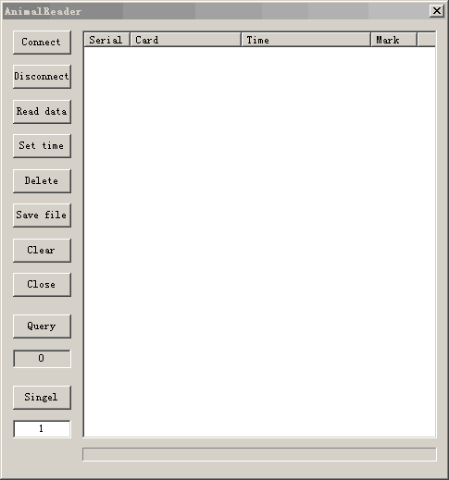
Figure 2 Database management software interface
Connect the reader to the computer with a USB cable, then open the database management software, click “Connect the Device” and then you will hear the beep sound and after popping up the connection success prompt, you can proceed to the next step (install the driver for the first time). The functions of the button are as follows:
“Disconnection”: Disconnect the software from the device.
“Read data”: Read all the information that is stored in the reader.
“Time setting”: The hand set sync is the same as the current computer time.
“Delete data”: Clear the tag information that is stored by the hand set (Note: the information will not be recoverable after it is cleared).
“Single data”: read a single piece of data.
“Number of queries”: Query the number of data that has already been stored in the current hand set.
“Eliminate display”: Eliminate the text box data.
“Save the file”: Save the exported data to an Excel spreadsheet.
“Delete duplicate number”: Delete the repeated data that is read.
“Open comparison file”: Open the comparison file on your computer.
“Download comparison file”: Download the comparison file to the device.
“Delete comparison file”: Delete the comparison file inside the device.
“Read access to internal record”: Reads the data from the beginning to the end of the input.

2 Wireless Data Transmission Function

Bluetooth
When the scanner is equipped with a Bluetooth module, the smart devices such as computers and mobile phones can be connected to the hand set via a Bluetooth interface so as to establish a communication link.
When using the Bluetooth function, turn on the wireless transmission function in the setting mode of the hand set, and use the host computer to search for adding a Bluetooth device. The name of the Bluetooth device of the hand set is “HID-KB-UART”. If you click “Auto Connect”, after the device link is successful, the card number read by the card reader will be automatically displayed at the cursor.

V. Notes
1. This product is an electronic product that is transported and stored according to the conventional electrical equipment.
2. Avoid falling or impacting the reader from a height.
3. Do not expose the reader in the environment with high temperatures, humidity or corrosion.
4. Non-professionals shall not open the reader's housing.
5. Please use the supplied data cable for online operation.
6. You had better not remove the battery back cover frequently.
7. Please remove the battery when you don't use it for a long time so as to avoid battery leakage and corrosion of the circuit board.

VI. Packing List
Serial number | Name
1 | Clavate hand set equipment
2 | USB data cable (with charging)
3 | Certificate
4 | “Hand Set Tag Reader Operating Manual”

