Hand-held label reader
User Manual

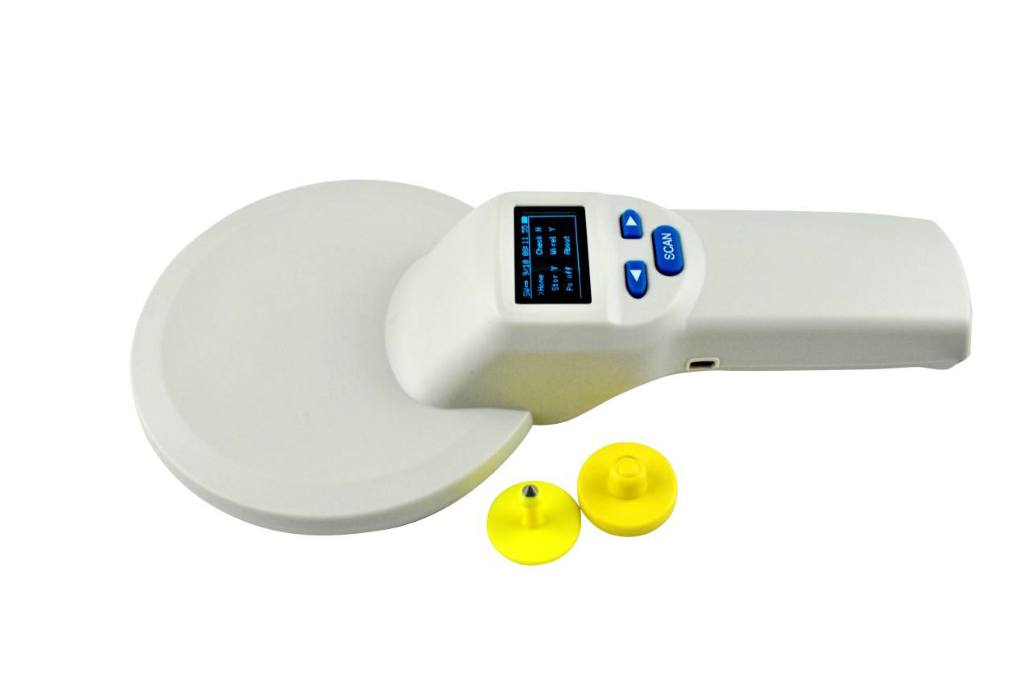

Content
1. Introduction 1
2.. Parameter 1
3. Function and operating 1
3.1 Display window 1
3.2 Basical operating 2
♦ Turn on the device 2
♦ Scan tag 2
♦ Data viewing 2
♦ Automatic shutdown 2
3.3 System setting 2
3.3.1:Return to main interface 4
3.3.2:Language settings 4
3.3.3:Storage settings 4
3.3.4:Repeat settings 4
3.3.5:Data mark settings 4
3.3.6:Data comparision settings 4
3.3.7:Buzzer settings 4
3.3.8:Delete data settings 5
3.3.9:Version NO. 5
3.3.10:Card reading selection 5
3.3.11:Bluetooth settings 5
3.3.12:Turn off the device 5
3.3.13:Resume to default settings 5
3.3.14: System time settings 5
4. Data transmission management 5
4.1 Database manegement software 5
4.2 Wireless data transmission function 6
♦ Buletooth 6
5. Considerations 7
6. Packing list 7

Introduction
The handset adopts wireless read-in mode and supports the electronic label in FDX-B (ISO 11784/85) format.
This scanner use high brightness OLED display which can be seen clearly in bright light environment. It can store max 20000 records of tag information with its built-in memory, users can upload the information to the computer through USB cable .
This product is stable with simple operation which is widely used for little animal management, resource management, railway inspection etc..

Parameter
Working Frequency | 134.2KHz
Support Tag | FDX-B (ISO11784/85)
Reading range | 2*12mm glass tube label >15cm  30mm animal ear marker >25cm (related to reader and use environment)
Standard | ISO11784/85
Reading time | <100ms
Prompt | 128*64 high brightness OLED、Buzzer
Power supply | Li-battery
Consumption | Less than 100mA
Storage capacity | 20000 records(UID+Time)
Battery life | >50000 times if full of electricity
Interface | USB2.0, bluetooth
Weight | 350g
Device dimension | L:28cm W:14.5cm H:5cm
Packing dimension | L:32cm W:18cm H:7cm
Language | Chinese, English, Japanese, Russian
Working Temp | -10℃～50℃
Storage Temp | -30℃～70℃

Function and operating

3.1 Display window
The device with a 128*64 high brightness OLED display which can display tag info, time communication mode，storage mode ect.

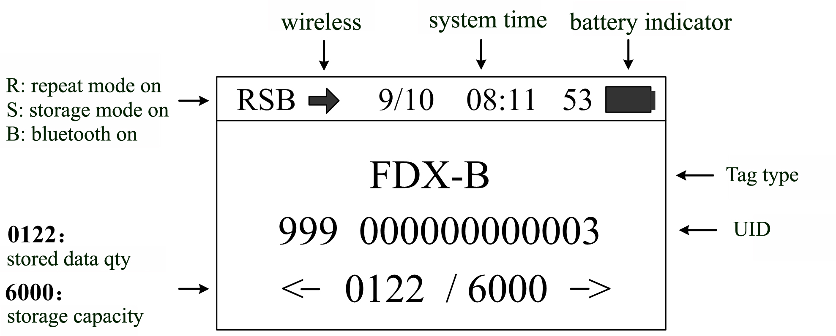

3.2 Basical operating

Turn on the device
Press“SCAN”for 2s when device is on off statu,device will be on and to main interface.

Scan tag
Press"Scan"on main interface，when display"scaning…"it can scan the tag. Buzzer willbeepone time when a tag is scanned, and display the tag info.If no tag in 10s, buzzer will beep and display “no tag”.

Data viewing
Press‘<’ and ‘>’ to check the tag information and time on main interface.

Automatic shutdown
In the power on state, there is no operation or data transmission within 30s, and the system will automatically shut down and enter the sleep state.

3.3 System setting.
Press and hold the "scan" button in the power on state, the reader will enter the setting mode, and the display interface is as shown in the figure below. Press the left and right buttons ('< key and' > 'key) to move the "arrow" cursor to select different functions for setting.
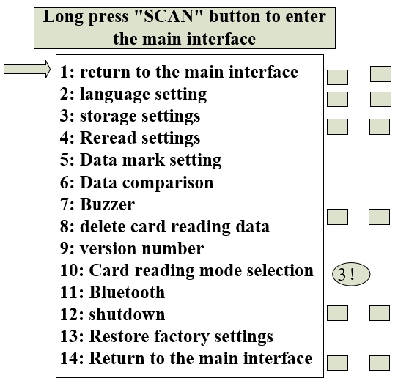
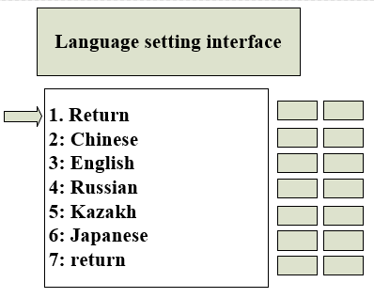

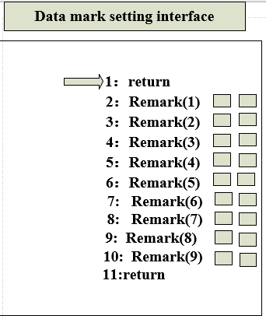

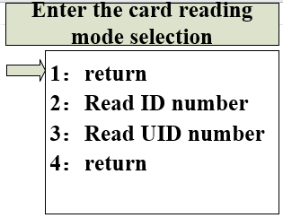

3.3.1 Return to the main interface
Move the "arrow" cursor to the "return to main interface" menu, and click the "scan" key to return to the main interface of power on scanning。

3.3.2 Language Settings
Default language: Chinese.
To change the language, move the "arrow" cursor to the "language setting" menu, press the "scan" key to enter the language setting menu and select through the "arrow" cursor.(The language of the device includes Chinese, English, Russian and Japanese)

3.3.3: Storage settings
Move the arrow cursor to the” storage settings” menu and press” scan” to switch between “Y” and ”N”.
(When the storage mode is set to "Y", the reader will automatically store the tag type, ID number and operation time after reading the tag information. If the storage mode is set to "n", no information will be stored)

3.3.4 Rereading settings
Move the arrow cursor to the “repeat settings” menu and press scan to switch between “Y” and “N”.
（The rereading mode is set to "Y" mode, and the device saves the same or different tag information , when it is set to "N" mode, the read tag information does not store the current data when the same tag information is stored in memory, and the buzzer beeps twice.）

3.3.5 Data mark settings
Move the "arrow" cursor to the "data mark" menu, and press the "scan" key to enter the data mark menu for marking.,default no mark.
（This function is a data mark function. You can set 9 groups of different marks to mark the tag type to be read）

3.3.6 Data comparision setting
Move the "arrow" cursor to the "data comparison" menu, press the "scan" key to switch between "Y" and "N". After setting the "Y" mode, the device enables the comparison function, and the data read will be compared with the data imported into the device. If there is the same tag information, the buzzer will give three prompts.

3.3.7 Buzzer setting
Move the arrow cursor to the buzzer menu and press scan to switch between Y and N.
（ "Y "indicates that the buzzer is turned on to the audible mode, and "N" indicates that the buzzer is turned off to the silent mode。）

3.3.8 Delete data setting
Move the arrow cursor to the Delete Data menu and press scan three times to delete all data in memory.
(After deleting the data, the data cannot be recovered. Please operate carefully。）

3.3.9 Verision No.
Move the "arrow" cursor to the "version No." menu, and press the "scan" key to check the factory version information and web address of the device

3.3.10 Card reading selection(not available yet)
Move the "arrow" cursor to the "card reading selection" menu, and click the "scan" key to enter the card reading mode selection.
(Note: Device factory read ID number by default, you can choose the mode to read by cursor, this function only supports FDX-B type label.

3.3.11 Bluetooth setting
Move the "arrow" cursor to the "Bluetooth" menu, press the "scan" key to switch between "Y" and "N", set to "Y" mode, turn on the Bluetooth function, set to "N" mode, turn off the Bluetooth function .
(After Bluetooth is turned on, you need to use the relevant Bluetooth device to connect. After the connection is successful, the device will send the current tag ID number to the relevant Bluetooth device through Bluetooth every time it reads the tag information)

3.3.12 Turn off the device
Move the "arrow" cursor to the "Turn off" menu, press the "scan" key to turn off the device.

3.3.13 Resume to default setting
Move the "arrow" cursor to the "Resume to default setting" menu, press the "scan" key to Resume to default setting
（This function is convenient for customers to enable in the case of setting wrongly, and restore the factory settings of the equipment after enabling）

3.3.14 System time setting
The system time of the device can be set by computer. For the operation method, please refer to the section "data transmission management"

Data transmission management
The information stored in the device can be uploaded to the computer through USB data line or wireless transmission for data management.

4.1Database manegement software
The device is equipped with USB2.0 interface. After the reader is connected to the computer with USB cable, the database management software can realize the operation of storage information query, data copy, data deletion and system time setting.
Software as below pic
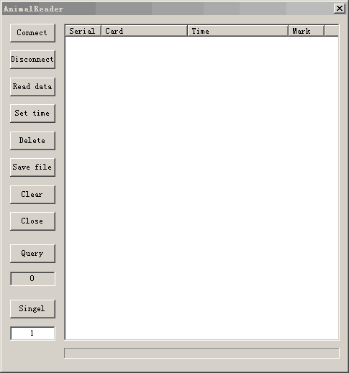
pic 1 database manegement software
Use USB cable to connect the reader to the computer, then open the database management software, click "connect device", hear a drop and pop up the connection success prompt, then proceed to the next operation (install the driver when using for the first time). Key functions are described as follows:
"Disconnect": disconnect: disconnect the software from the device.
"Read data" : read all the information stored in the device.
"Set time" : the handset synchronization is the same as the current computer time.
"Delete data": clear the tag information stored in the device (Note: the information will not be recovered after clearing).
"Single data": reading of single data.
"Number of queries": queries the qty of the records stored in the current handset.
"Clear" : clears the text box data.
"Save" : export data to an excel file.

4.2 Wireless data transmission function
♦ Bluetooth
When the scanner is equipped with Bluetooth module, the computer, mobile phone and other intelligent devices can be connected with the sanner through Bluetooth interface to establish a communication link.
When using the Bluetooth function, turn on the wireless transmission function in the setting mode of the device, and use the upper computer to search and add Bluetooth devices. The Bluetooth device name of the device is "HID-KB-UART". Select and click auto connect. After the device is successfully connected, the tag ID read by the scanner will be displayed automatically at the cursor.

Precautions
1. This product is an electronic product, which is transported and stored according to the conventional electrical equipment.
2. Avoid reader falling or impact from high place.
3. Do not put the reader in high temperature, humidity or corrosive environment.
4. Non professionals should not open the reader shell.
5. Please use the data line provided for online operation.
6. Try not to remove the battery back cover frequently.
7. Please take out the battery when it is not used for a long time to avoid battery leakage and corrosion of circuit board

Packing list
Item | Name
1 | 1pcs*USB cable
2 | Wireless Data Receiving Head (Optional)
3 | USB Charger
4 | 3 Section 5 Lithium Battery
5 | Instructions for the Use of Hand-held Label Reader

